

MSP - 021

PROCEDURE FOR DOCUMENT MANAGEMENT

TABLE OF CONTENTS

TABLE OF CONTENTS 2
APPROVAL AUTHORITY 3
RECORD OF AMENDMENTS 4
DISTRIBUTION LIST 5
LIST OF ABBREVIATIONS 6
1. Objective 7
2. Scope 7
3. Responsibilities 7
4. Definitions 8
5. Procedure 8
5.1 Documents 8
5.2 Documentation Structure 8
5.3 Identification of Documents & Change Control 10
5.4 Document Access 11
5.5 Stamping System for Document Control 12
5.6 Document Creation and Revision Procedure 13
5.7 Periodic Review of Documents 14
5.8 Control of documents of external origin 16
5.9 Document format settings and style 16
5.10 Document Structure and format 17
6. Quality Control 19
7. Related Documents 19
8. Reference Regulations & Guidelines 19
9. Related Records 19
Appendix - 1: New Document Creation – Process Flow 20
Appendix - 2: Existing Document Review – Process Flow 21
Appendix - 3: TRUSTlab’s Internal Departments 22
Appendix - 4: Document Types Used at TRUSTlab 23

APPROVAL AUTHORITY

Prepared by: | Quality Manager | Dr. Sai Varun  Name | Date: 14/11/2024
 |  | Signature
Reviewed & Issued by: | Laboratory Head | Dr. Abdul Aleem  Name | Date: 14/11/2024

Signature
Approved by: | Chairman & Managing Director | Mr. Venkata Cherukuri  Name | Date: 14/11/2024
 |  | Signature

RECORD OF AMENDMENTS

S. No. | Ver. No. | Ver. Date | Rev. No. | Rev. Date | Description of Changes

Document Copy No. | Name / Designation of the holder of the document copy | Type of Copy | Version No. | Revision No.
01/10 | Managing Director | Controlled Copy | 01 | 00
02/10
03/10
04/10
05/10
06/10
07/10
08/10
09/10
10/10

DISTRIBUTION LIST

LIST OF ABBREVIATIONS
S. No. | Abbreviations | Expansion
1 | CAPA | Corrective Action & Preventive Action
2 | DCC | Document Control Coordinator
3 | DOMAS | Document Management System
4 | FOM | Form
5 | GE | General
6 | ISO | International Organization for Standardization
7 | LIMS | Laboratory Information Management System
8 | MAN | Manual
9 | MSP | Management System Procedure
10 | NABL | National Accreditation Board for Testing and Calibration Laboratories
11 | QA | Quality Assurance
12 | QM | Quality Manager
13 | QT QMS | Quality comes before Trust Quality Management System
14 | SME | Subject Matter Expert
15 | SOP | Standard Operating Procedure
16 | TAMS | TRUSTlab Asset Management Software
17 | TDPL | TRUSTlab Diagnostics Private Limited

- Objective
This procedure describes the process for the development, review, authorization, control and distribution of controlled documents
- Scope
TRUSTlab Quality Management documents include internally generated documents, which provide instructions regarding how to conduct business as well as blank documents which provide a format for recording information. Quality Management documents also include those of external origin used in the implementation of the quality system, such as standards, regulations, equipment software and manufacturers' manuals.
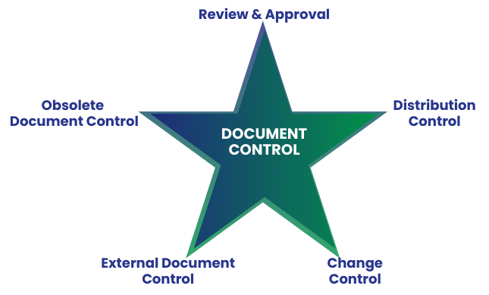
- Responsibilities
  - The Document Control Coordinator (DCC) is a quality management position appointed by the TRUSTlab Management with the responsibility for maintaining this procedure that forms part of the TRUSTlab Quality System, including uploading and maintaining the latest version on the QT QMS software. The DCC is also responsible for coordinating TRUSTlab’s employees regarding the revision of this procedure.
  - For the purposes of this procedure, Subject Matter Experts (SMEs) are persons deemed competent, experienced, and knowledgeable by the TRUSTlab Management in the topic of the procedure, standards, guidance or other subject matter for which this procedure is intended. This procedure has been prepared with valuable inputs from SMEs.
  - The Quality Manager (QM) is responsible for the preparation of this document, as well as for its implementation, and continuous monitoring to ensure organizational compliance with this procedure.
  - All TRUSTlab staff (including contract personnel) are responsible for complying with this procedure.
  - TRUSTlab Management is responsible for approving and signing the finalized version of this procedure that forms part of the TRUSTlab Quality System.
  - In situations where the DCC is absent or unavailable, the QM will take over the responsibilities of the DCC to ensure continuity of operations. Likewise, if QM is absent or unavailable, the Deputy Lab Head will step in to fulfil QM’s responsibilities, maintaining seamless functionality within the organization. In situations where both the QM and Deputy Lab Head are unavailable, the Lab Head will step in to additionally fulfill QM’s responsibilities.
- Definitions
- Document: A written, printed or digital record that contains information, instructions or data and serves as a reference or proof of activities, decisions or processes.
- Documentation: The process of creating, organizing, and maintaining the above-mentioned records.
- Procedure

Documents
There are several documents that form part of the TRUSTlab Quality System, including Policies, Procedures, Manuals, Work Instructions, Forms, Records, Templates, Guidelines, Checklists, Logs, Calibration Certificates, Training Materials, Audit Reports, and Corrective and Preventive Action (CAPA) documentation. These documents collectively ensure standardization, compliance with regulatory requirements, effective communication, traceability of activities, and support for continuous quality improvement across all organizational processes.

Documentation Structure
- The documents within TRUSTlab are structured into four major categories called Levels, each serving a distinct purpose and contributing to the overall effectiveness and compliance of the Management System.
- Documentation Hierarchy
  - Level 1: This consists of the TRUSTlab Policies, Manuals, contracts and agreements.
  - Level 2: The level consists of procedures.
  - Level 3: Consists of guides, work instructions.
  - Level 4: Consists of forms, calculation tables, logs, matrices, formats, registers, questionnaires, schedules and programmes.
These categories help organize and streamline the documentation process, ensuring clarity, consistency, and traceability.
- Here’s an overview of common document types used as part of TRUSTlab Quality System and their definitions, as well as how they may be used in different storage formats (digital or paper):
  - Manuals
TRUSTlab Manuals outline the procedures that are developed to meet the organization’s policies and the commitments to meet the requirements of applicable standards, such as ISO 9001 and ISO 15189.
  - Policies
TRUSTlab Policies are high-level directives that communicate our organization’s intentions and strategic approach to particular subjects, such as quality, safety, environmental sustainability, and customer service. Our policies provide a framework for decision-making and ensure consistency and alignment with TRUSTlab goals, values, and regulatory requirements.
  - Procedures
TRUSTlab Procedures are a comprehensive compilation that details the flow of information and communication channels within the organization, ensuring the effective execution of its various activities.
  - Forms and Formats
TRUSTlab Forms and Formats serve as structured tools for recording data and information generated during the organization’s operations.
  - Record
TRUSTlab Records serve as evidence of compliance with processes, activities, and standards. These include sets of completed forms, reports, certificates and other essential documents.
  - Folder
TRUSTlab Folders provide a structured way to manage data files, allowing users to group related files together for easy access and organization.
  - Process Flowchart
TRUSTlab Process Flowcharts are visual representations of a sequence of steps or actions involved in a process.
  - Guide
TRUSTlab Guides are a generic overview of a specific task or process, which may include explanations, tips, troubleshooting steps designed to help our employees.
  - Register
TRUSTlab Registers are physical register books used to document and track specific types of information systematically.
  - Plan
TRUSTlab Plans are a detailed proposal or strategy designed to achieve a specific goal or objective. They outline what needs to be done, how it will be accomplished, who will be responsible, and task-wise timelines.
  - Standards
A Standard is a documented agreement or specification that provides criteria, guidelines or requirements to ensure consistency, quality and interoperability in products, services or processes. These include in-house developed standards and those that are externally acquired.
- Each document and documentation type is assigned a unique three-character code, which is incorporated into the document numbers as part of the alphanumeric naming scheme. Refer to Appendix 3 for the different document types which are used at TRUSTlab.

Identification of Documents & Change Control
- All internally issued documents that form part of the TRUSTlab Quality System are assigned a document number using the specified alphanumeric scheme:
  - Company name (4-Letter Code)
  - Department (2-Letter Code) (Refer to Appendix 3 for names of all internal departments)
  - Document Type (3-Letter Code) (Refer to Appendix 4)
  - Identification Sequence No. (3-Digit Code) (starting from 001 onwards)
  - Example of a Document No.: TDPL/QA/SOP – 001
- All the internal documents and some external documents, regardless of the document type, must contain the following elements:
  - Section Title
  - Document name
  - Unique document identification number
  - Version number & Date
  - Revision number & Date
  - Page number and total number of pages
  - Record of Amendments
  - Designation and signatures of preparation, revision & approval authorities
- A Master list identifying the current revision status of TRUSTlab Quality System documents is available on the QT QMS software. The DCC maintains the list.
- Handwritten amendments to any issued TRUSTlab Quality System Documents are strictly prohibited, to ensure the integrity, consistency, and traceability of the documentation. Any required changes must follow the established Document Creation and Revision Procedure (Refer to section 5.6).

Document Access
- To promote both environmental sustainability and customer satisfaction, TRUSTlab has adopted a policy of minimizing the use of paper (hard copies). Whenever possible, documents will be obtained/created and stored electronically.
- To support this policy, TRUSTlab has developed and implemented various software solutions and electronic storage mechanisms to efficiently store and retrieve data related to its laboratory activities. TRUSTlab’s customized in-house designed & developed Quality software is called “QT QMS”. Most of the documents that form part of the TRUSTlab Quality System are stored in the QT QMS software which is accessible to authorized individuals 24 hours a day, 7 days a week. Other software where documents related to quality are stored include DOMAS, TAMS & TRUSTLab LIMS.
- The approved level 1, 2 and 3 documents are uploaded onto the relevant cloud-based software in the “read only” Word document format. Only the DCC is permitted to upload documents. All documents are uploaded in Word format (with an option to upload in pdf format, if so required).
- The documents have read-only access. It is prohibited to copy or print Level 1, 2 and 3 documents.
- Uncontrolled documents of Level 4 may be printed. The documents are only accessed by TRUSTLAB staff. Any printed copy of a controlled document is deemed uncontrolled
- A TRUSTlab employee will download and print a single copy of a Level 4 document only when it needs to be used, to avoid using available printed extras that may not be the most current version of the document.
- Hard copies are maintained only in cases where TRUSTlab does not have control over obtaining or recording a document related to the TRUSTlab Quality System in a soft copy format. This includes, but is not limited to, instances where external contractors provide equipment maintenance or calibration certificates, employee training certificates, or other documents as proof of service, product delivery or training completion.
- However, every hard copy at TRUSTlab is digitized and stored within the appropriate TRUSTlab proprietary software or licensed software that TRUSTlab has paid for and has access to.

Stamping System for Document Control
- The DCC is responsible for ensuring that all internally issued documents that form the TRUSTlab Quality System are readily available and accessible.
- MASTER DOCUMENT - The verified and approved copies in the quality system are labeled as MASTER COPY and stamped in blue at the bottom left of the document.
- CONTROLLED DOCUMENT - Every copy (photocopies) meant for use in the organization is labeled as CONTROLLED COPY and stamped in black at the bottom left of the document.
- UNCONTROLLED DOCUMENT - All other electronic or printed copies are labeled as UNCONTROLLED COPY and stamped in black at the bottom left of the document.
- OBSOLETE DOCUMENT - All the past versions or expired documents are labeled as OBSOLETE COPY and stamped in red.
- PAGE CONTROL - Every page of the document will be serially numbered. This numbering system in the quality system manual contains the total number of pages and the page number of the individual page.
- FOR INFORMATION ONLY - If any member of TRUSTlab wishes to retain a copy of a superseded version of a document, specific permission must be obtained from the Quality Manager. Any such copies will be clearly marked as “For Information Only.” This option is strictly limited to Standard Operating Procedures (SOPs).
- If any member of TRUSTlab requires a copy of a document that has not been distributed, they may submit a written request to the Quality Manager. The Quality Manager will assess the need for the document and, if deemed necessary, arrange for its issuance to the individual.

Document Creation and Revision Procedure
- The process established to develop, review, authorize, control and distribute internal documents related to the TRUSTlab Quality System consists of the following steps:
- A request for a new document can be raised by any employee of TRUSTlab.
- Once the need for a new document has been validated by QM in consultation with TRUSTlab Management, an author and a set of reviewers will then be designated with the task of preparing the document. An SME is usually assigned as either the author or a reviewer. Once these assignments have been made, the QM notifies the DCC via email and the DCC notifies the author and reviewers via email.
- The DCC will set up the document title, the document number, author and reviewer/s details in the QT QMS software and provide the author with the document access in QT QMS software. The DCC will also notify the author and the reviewers about the document completion deadlines via email.
- The author will prepare the initial draft and upload it to the Draft Folder in the QT QMS software.
- The selected reviewers will be notified via email about the uploaded document, enabling them to provide their comments to the author.
- The author will address these comments and then submit a second draft to the reviewers.
- If necessary, the reviewers will once again provide comments to the author.
- Steps e, f & g are repeated until all comments are addressed.
- Once all comments have been addressed, the author of the document will check the document before notifying the DCC via email for a format check and to assign the relevant Version Number and date.
- Handwritten amendments are not permitted on documents of Levels 1 through 4.
- The document will then be submitted to the QM for a final review and signatures.
- The final stage is submission to the Management for approval and signature.
- The approved and signed document by TRUSTlab Management will then be uploaded to the Master Folder in the QT QMS software by the DCC, which becomes the Master Copy and will be stamped as such.
- A need for a revision may arise due to a significant change, for e.g. a change in the test procedure – in such cases too, the above procedure is followed.
- When documents are revised and uploaded into QT QMS the earlier version will automatically move to the Obsolete Folder and stamped as Obsolete Copy in the QT QMS software.
- Amendments to the original document are indicated by assigning a revision number. The initial version is assigned a revision number of “00,” with subsequent revisions numbered sequentially (e.g., “01” for the first revision, “02” for the second, and so on).
- The following situations call for a change of the Version No. of a document:
- If the number of revisions exceeds 10,
- If all procedures within the document are changed,
- Significant or major changes are required.

Periodic Review of Documents
- Internal documents are subject to periodic review, and where necessary, revised to ensure continuing suitability and conformance with applicable requirements.
- Level 1 documents are reviewed every 2 years while Level 2 & 3 every 3 years and Level 4 are reviewed every 12 months. The exception to the above timeframe is that reviews of documents may be carried out whenever deemed necessary.
- Reviews ensure staff have the most current, complete, and accurate information to do their job. Results of document reviews are maintained as track changes on the relevant document. A review does not necessarily result in a revision of the document; however, this acts as evidence that the document was seen and is still fit for the purpose it is meant for.
- Document reviews are also conducted during internal audits.
- Changes to management system documents are reviewed and approved by the same functions that performed the original review and approval.
- This schedule is applicable to all TRUSTlab internal documents issued after the effective date of this Management System Procedure.
- In January of every year, the DCC will develop and maintain a document review schedule for the upcoming review period. The schedule will include the effective date of the most recent version of the document and the review date.
- The DCC will update the review schedule as additional reviews are conducted or new documents are developed. The following procedure will be adopted:
- The QM will consult management if there is a need to assign a new author based on staff changes. The DCC will then notify the assigned author via email of the need for the review.
- The author will review the procedure to determine if updates are needed. If yes, the author will notify the QM and the DCC via email and proceed to step 3 below. If no updates are needed, the author will notify the QM and the DCC via email. The DCC will maintain a copy of this email.
- If required, the DCC will consult with the QM and Management to assign reviewers and will notify the author of the reviewers.
- The author will update the procedure and provide the draft to the reviewers.
- The reviewers will provide comments to the author.
- Steps d & e are repeated until all comments are addressed.
- Once all comments have been addressed, the document will be submitted to the DCC for a format check and effective date assignment.
- The document will then be submitted to QM for final review and signature. Prior to issue, the documents are reviewed by QM to ensure clarity, accuracy, adequacy and proper structure.
- The final stage is submission for approval and signature. Level 1 documents are approved by the Management (Administration, General and some laboratory documents) and Lab Head (Laboratory related documents) while Level 2 documents are approved by the Management and Level 3 are approved by the Laboratory Head. Level 4 documents are approved by the Laboratory Head.
- The Quality Manager maintains all the controlled copies up to date. The DCC will advise all affected personnel to dispose of electronic and hard copies of the superseded documents to preclude unintended use. It is the individual's responsibility to ensure that every hard /soft copy of documents in their possession is the latest version of it.
- Document Retention Period: For the retention period of documents at TRUSTlab, refer to the Master List of Documents (TDPL/MG/FOM-001).

Control of documents of external origin
- Documents of external origin referenced in the implementation of the TRUSTlab Quality System may include national and international standards, manufacturer’s manuals, equipment software, NABL standards, and other associated types of information. External documents will be reviewed for context to determine their applicability in the TRUSTlab Quality System. This review will be conducted by the QM with assistance from the SME of the TRUSTlab Quality System document in which the external document is going to be referenced.
- When applicable, the external origin documents will be documented as appropriate, with the title, document control number, if any, as described in Section 5.3 of this procedure, most recent and/or approved revision/edition number, and year of publication.
- The DCC will maintain a list of all external documents. The DCC will review the list each January and consult with the external personnel to determine if updates are available. If they are available, the updated version will be labeled with the next revision number of the document, and the obsolete copy will be removed from service.

Document format settings and style
- Writing style
Documents are generated in a concise, step-by-step, easy-to-read format.
The information presented is unambiguous and not overly complicated.
Information is conveyed clearly and explicitly to remove any doubt as to what is required.
- Font Type and Colour
The Palatino Linotype font style in black colour is used.
- Font Size
The following font sizes are used in all management system documents:
- 14 for Headings
- 12 for Subheadings
- 11 for Body Text
- 8 for Header Text
- 7 for Footer Text
- Numbering and Heading Levels
The numbering of heading levels is done in Arabic Numerals.
Subheadings may be numbered alphabetically or with Roman Numerals.
- Bolding
For Abbreviations, Headings/Subheadings, Page numbers and Focused Text.
- Alignment of Text
The following alignment is used in all TRUSTlab documents:
- Left - for all headings and subheadings
- Center - for the institution logo on the cover page
- Page layout
Portrait for the written text in the main document body. Images may be placed in landscape view, as per the image’s fit in the page.
- Paper Size
All documents will be designed for the A4 paper-size - 210 x 297 mm.
Page margins - Normal; Left, right, top and bottom are set at 1". Footers and headers are set at 0.5".
- Line Spacing: Single
- Page Numbering: Page numbers are in the middle of the footer on every page along with the total number of pages in the document e.g. Page 1 of 9.

Document Structure and format
- All documents on the same level adopt a consistent layout and presentation.
- The structure and format of Level 1, 2 and 3 documents is as depicted here:
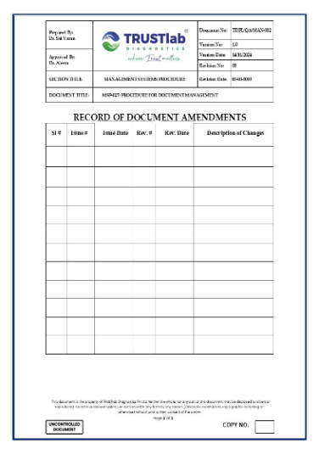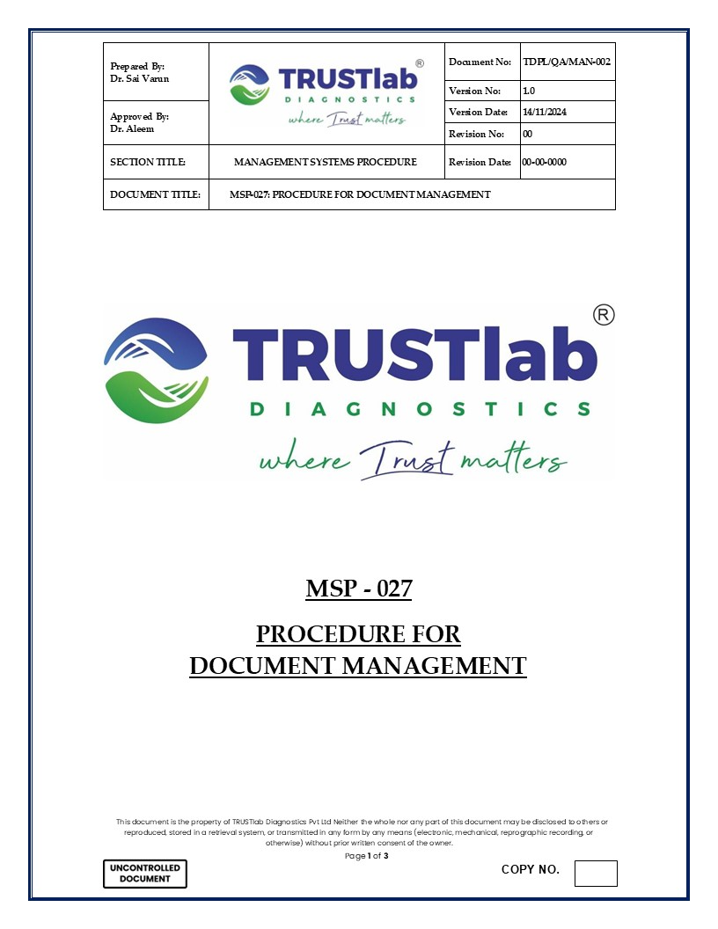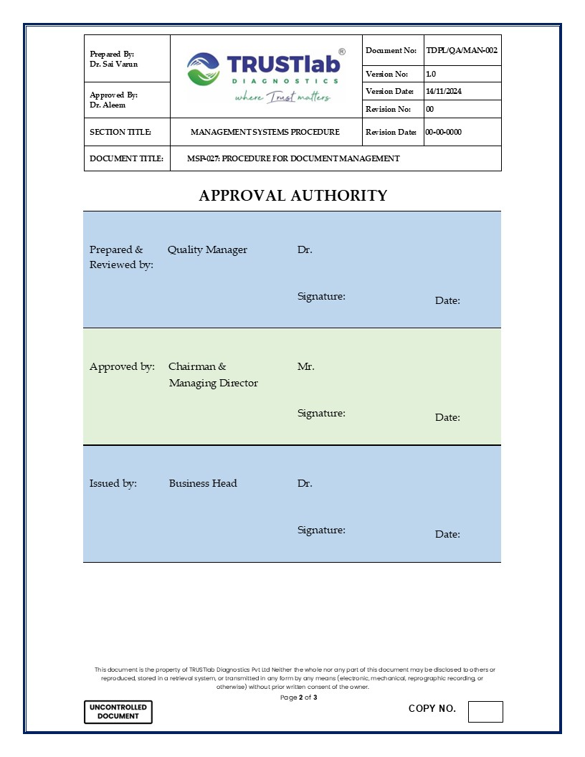
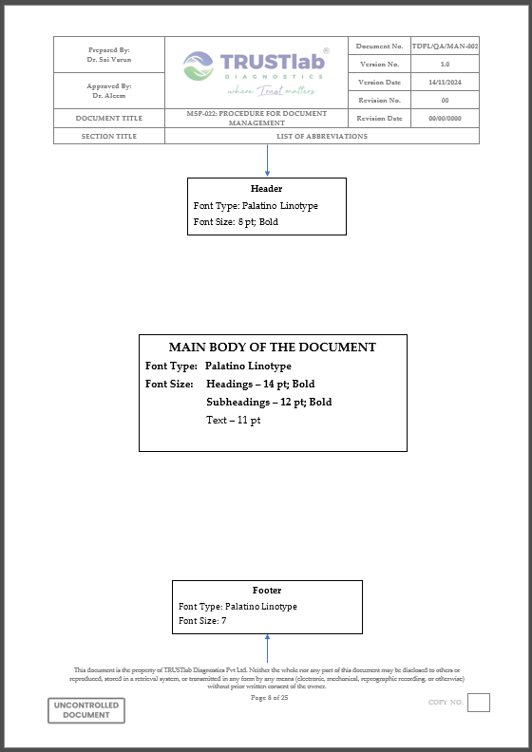
- Guides, Manuals and other documents in Level 1 may include a table of contents for the ease of navigation where the document has more than 10 pages (cover page and table of contents excluded).
- Quality Control
The Quality Manager or designee will do random Quality Control checks to ensure that this SOP is implemented as written. If Quality control checks reveal non-compliance with this SOP, the SOP deviations and violations will be investigated, corrective and preventive action initiated, implemented, reviewed and closed out. All corrective and preventive action should be documented in the Non-Conformity & Corrective Action Form (TDPL/GE/FOM-021).
- Related Documents
  - N/A.
- Reference Regulations & Guidelines
  - Specific Criteria for Accreditation of Medical Laboratories (NABL 112 A; Issue 01)
  - Guidance document: Medical Laboratories (NABL 112B; Issue 01)
  - ISO 15189:2022 Medical Laboratories – Requirements for Quality and Competence
- Related Records
  - Non-Conformity & Corrective Action Form (TDPL/GE/FOM-021)
  - Master List of Documents (TDPL/MG/FOM-001)

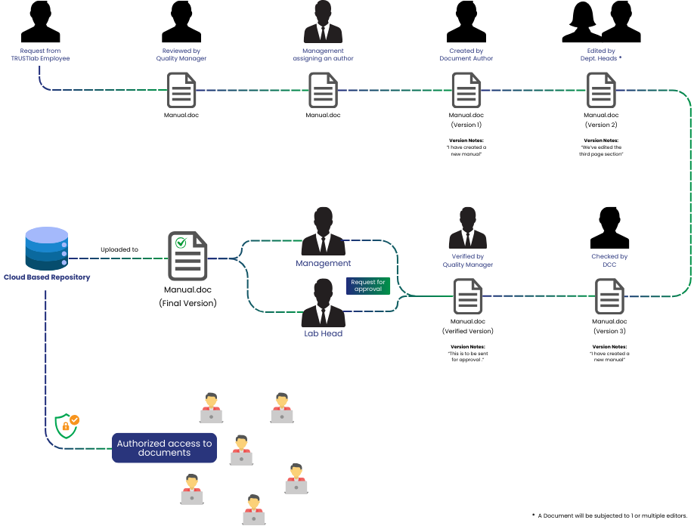
Appendix - 1: New Document Creation – Process Flow

Appendix - 2: Existing Document Review – Process Flow
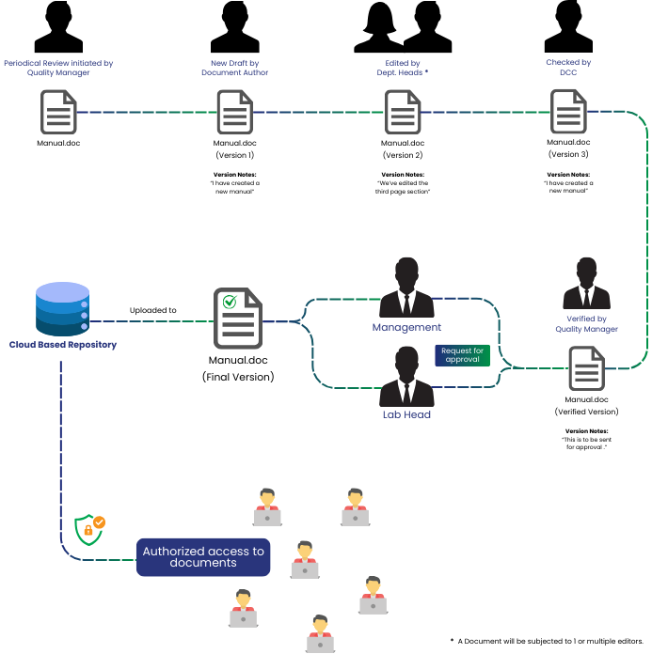

Appendix - 3: TRUSTlab’s Internal Departments
The following departments are integral to TRUSTlab’s business operations. Each department is assigned a unique two-letter code, which is incorporated into the document numbers as part of the alphanumeric scheme:
AP | Accounts Payable | CY | Cytology | MG | Management
AR | Accounts Receivable | FI | Finance | MI | Microbiology
AS | Accession | FL | Facilities | OH | Occupational Health & Safety
AU | Audit | GE | General | PR | Procurement
BC | Biochemistry | HM | Haematology | QA | Quality Assurance
BE | Biomedical Engineering | HP | Histopathology | RM | Risk Management
CG | Cytogenetics | HR | Human Resource | SE | Serology
CL | Clinical Operations (General) | IT | Information Technology | SL | Sales
CP | Clinical Pathology | LG | Legal | SM | Stock Management
CR | Credit | LO | Logistics
CT | Cytopathology | MB | Molecular Biology

Appendix - 4: Document Types Used at TRUSTlab
CAT | Calculation table | CES | Certification scope | CAG | Confidentiality Agreement
CFC | Certification Flow Chart | COC | Competence criteria | CTC | Certification terms & conditions
FAT | Format | FOM | Form | FOL | Folder
GID | Guide | LIC | Licensing Contract | MAN | Manual
MAT | Matrix | PME | Programme | POL | Policies
PLN | Plan | PFC | Process Flow Chart | QER | Questionnaire
REC | Records | REG | Register | SOP | Procedure
STD | Standards | SED | Schedule
WIS | Work Instructions | OST | Organisational Chart | LFA | Lab Franchise Agreement
CFA | Collection Centre Franchise Agreement | PLA | Property Lease Agreement | COA | Contractor Agreement
CNA | Consultant Agreement | CSA | Customer Service Agreement | LSA | Lab Service Agreement

